**PGE 392K In Class Problem**

**Oct 13, 2020**

**Copy all of your previous files for 2D into a new folder** and then adapt your 2D code to include heterogeneities (area, permeability, grid size) and anisotropy (grid size and permeability). Specifically, do the following:

1. Create a function/subroutine file that when sent two grid blocks (e.g. L1, L2) as well as reservoir, fluid, and numerical properties, the interblock transmissibility between those two blocks is returned. Recall: since permeability and grid size may be anisotropic, calculations should be different in the x- and y- directions so you may want to specify if you are computing the x- or y- direction transmissibility.



Where,







1. Test your function file from command window by sending any two blocks
2. In your main loop to compute the Transmissibility (**T**) matrix, call your function/subroutine file where appropriate. The inputs to the function file may be L,L-1; L,L+1; L, L-NX; L+NX; or L,L
3. Test your code to make sure it is computing the right answer.
   1. Use NX=NY=3 grids (uniform grids).
   2. L=10,000, W=8,000, h= 20 ft
   3. kx = [50 40 30 60 50 40 70 60 50]; ky=2*kx
   4. porosity = 20%, viscosity = 1 cp; FVF =1 RB/STB; compressibility = 1E-6 psi-1; endpt relative permeability = 1.0;
   5. Initial pressure = 1000 psi
   6. BC at x= 0 (Dirichlet, P=2000 psi). BC at other 3 faces (no flow, neumann)

Solution (T = scf/psi-day; B= scf/psi; Q = scf/day)

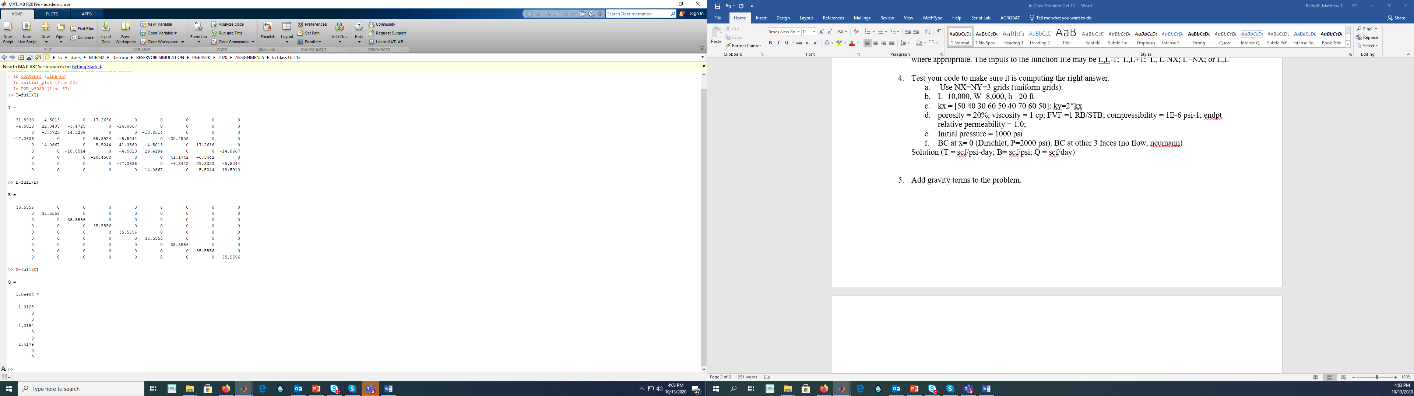

1. Add gravity terms to the problem.